**THIS IS A SUGGESTION ONLY**

For our pitch today we would like to talk about Bill Joy’s controversial article “Why the Future Doesn’t Need Us” from 2000.So two questions may pop-up in your head: Who’s Bill Joy and what’s important about his article? Well the answers are luckily quite interlinked! William Nelson “Bill” Joy is an American computer scientist, co-founder of Sun Microsystems and original author of the vi text editor.



The reason his article is important is because it gives us a rare and complete insight from within the ‘technology’ sector into what the future could hold for us as a species.



Bill’s article is a precautionary forewarning into the dangers of unrestricted technology and proposes a very dystopian view of the future. He has been commonly referred to as “neo-Luddite” although he denies this himself, backing himself with his extensive credentials and research

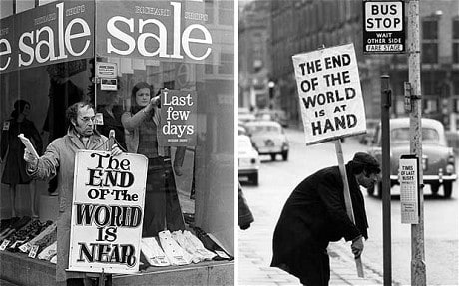

Possibly his opinions have surfaced from being around technology for so long and watching it develop as quickly as it has

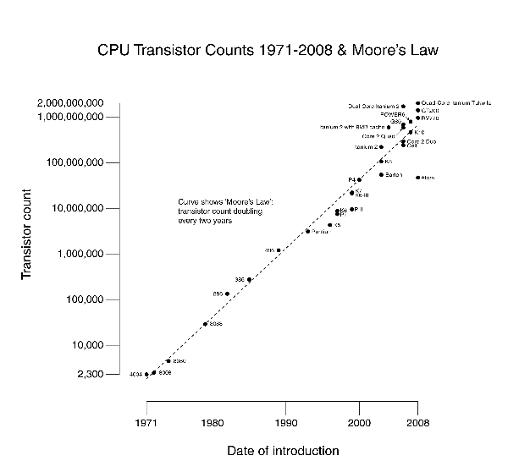

He writes, “Perhaps it is always hard to see the bigger impact while you are in the vortex of a change” and that the most common fault of scientists is “failing to understand the consequences of (their) inventions”.

Throughout his article Joy discusses the views of specialists in other scientific fields as well as some unorthodox sources. For example, he quotes Hans Moravec. “Moravec is one of the leaders in robotics research, and was a founder of the world’s largest robotics research program, at Carnegie Mellon University.” He is quite clearly a very credible source to refer to. Moravec himself believed that robots would rapidly displace and replace humans in almost everything.

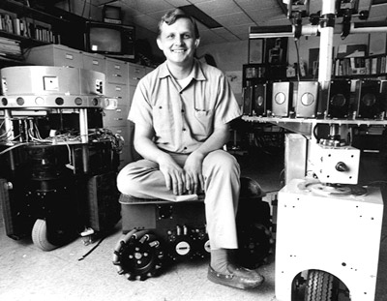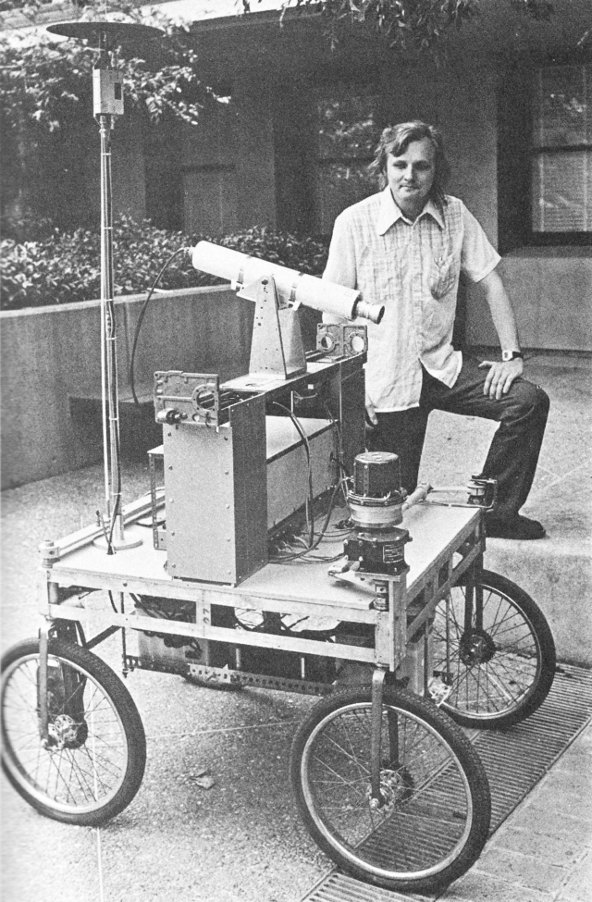

However, he was optimistically hopeful: “Government coerces nonmarket behavior, especially by collecting taxes. Judiciously applied, governmental coercion could support human populations in high style on the fruits of robot labor, perhaps for a long while.”

This is actually a fairly optimistic viewpoint and one of societal determinism, where governments and societies would control the shaping of the future and technology. However, a simple examination of reality tells us the opposite! 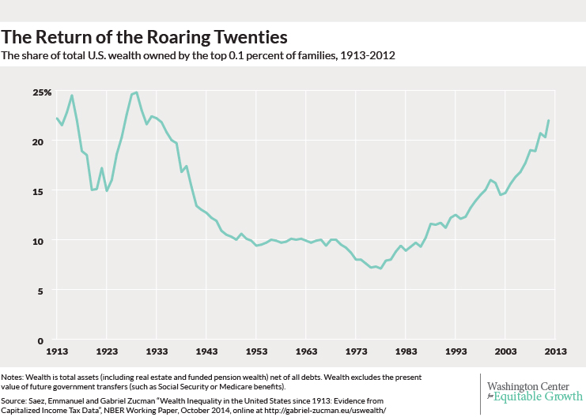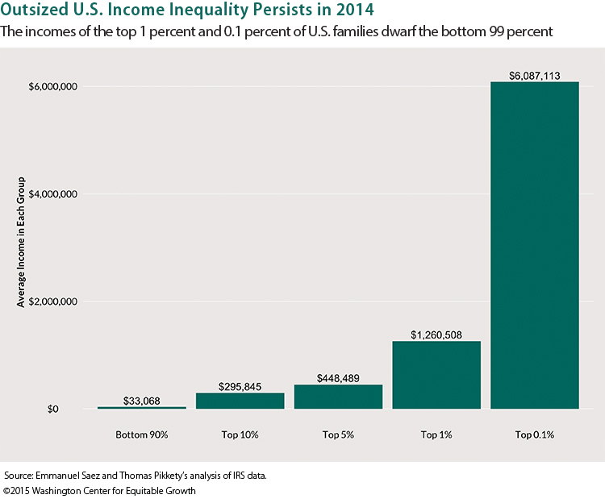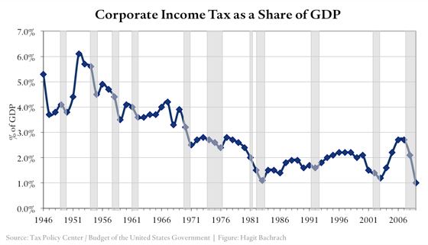

If we look at current trends in corporate tax we see effective corporate taxes falling as percent of gdp as well as percentage wise. We also see an interesting trend in income inequality where the richest in control are getting even richer than the rest of us.

The reality is that these rapid technological advancements aren’t as easily controllable or re-distributable as Moravec suggested. The development of revolutionary technology has always been succeeded by a perceptible change in the status quo. 

The idea that we could simply ‘tax’ the people in control once they control all the means of production is simply techno-utopian optimism! It’s an attempt to simply use old solutions to new problems. Bill Joy himself didn’t subscribe to these views but instead advised greater caution and deliberation.



Joy’s fear of the future shines through when you examine his opinions in the article. Joy had always looked on the thought of robots taking over the world as science fiction before he met Ray Kurzweil, who suggested in his talk that robotic technologies are actually a lot closer to reality than he once thought. 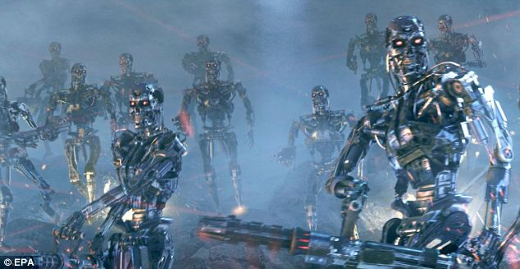

He had a utopian view of our future with technological advances allowing us to fuse with robots and become immortal. However, Joy felt unease while reading a partial preprint of his book ‘The Age of Spiritual Machines’, as he felt Ray was understating the dangers.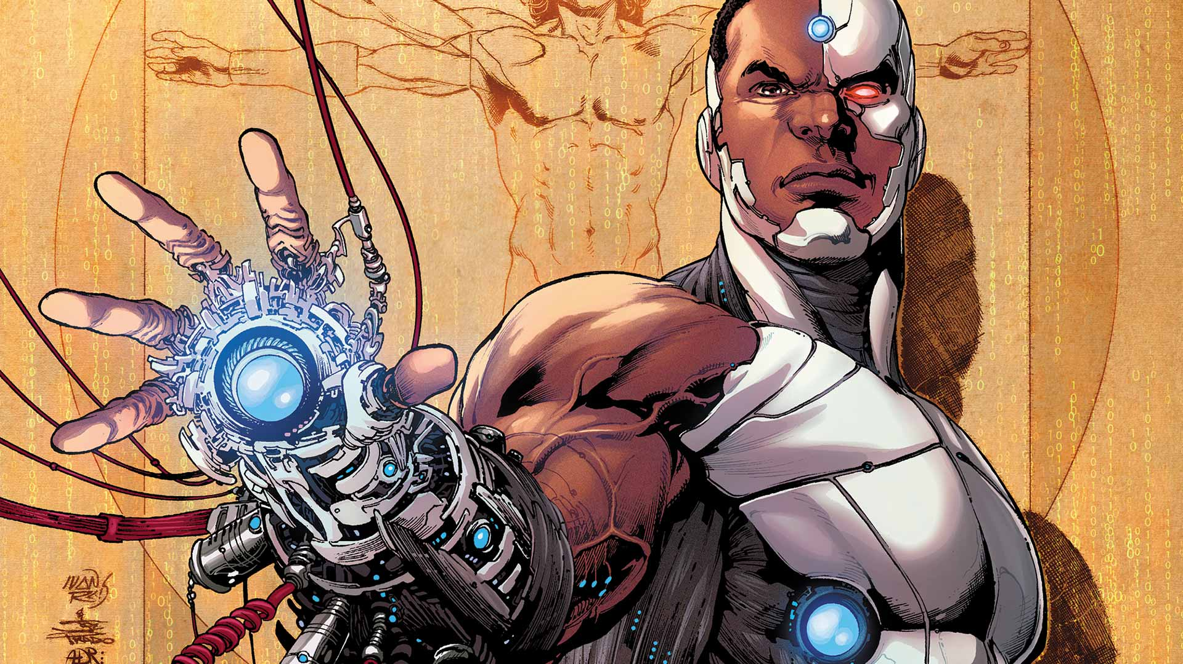

As an almost counterpoint to this idea of utopian progress of technology, Joy presents an extract from the book of a man called Theodore Kaczynski, commonly known as the Unabomber

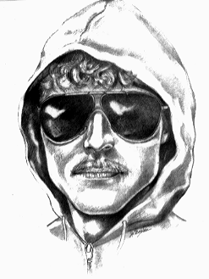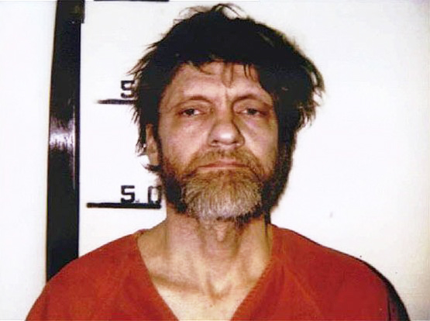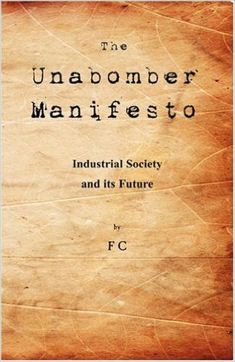

Like Moravec, Kaczynski had a dystopian view on the future where robots will be able to do everything better than humans and thus human effort would become useless. He posits two possible scenarios. The first where machines are so advanced that they can think and make their own decisions without human oversight, or all of the advance technology is controlled by the elite who controls the world.



If the machines can make their own decisions, they wouldn’t need people anymore. The problem is that we would need those machines, we couldn’t live without them and yet at the same time we would be completely useless and the machines could get rid of us easily. We wouldn’t be able to shut them down because we would be dependent on them. While this may seem like an alarmist dystopian view, it is not without merit as we see our society become continuously more reliant on machines to make choices for us. With the advent of driverless cars and intelligent AI we may be far closer to the finish line than we once thought.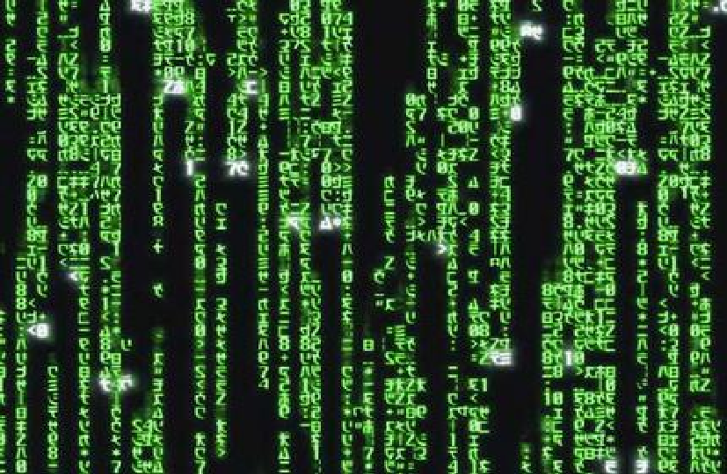

On the other hand, if robots couldn’t decide and think by themselves, people would need to control them. If that happens, the machines will probably be in the hands of tiny elite, which means that those people wouldn’t need other people anymore because all of the work is done by the machines and humans are completely useless. This is not actually much different from the first scenario with the sole exception that it is possible to naively believe that these elites would be benevolently looking after our needs, like as if we were their pets.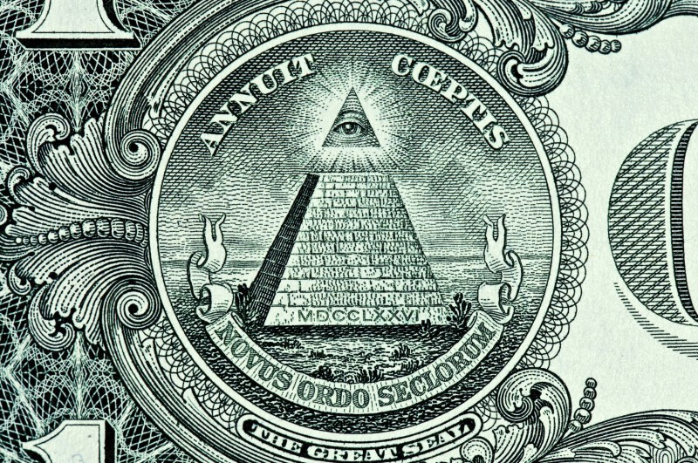

While Joy himself believes that the Unabomber was an extremist and perhaps a bit too dystopian, he thinks that the Unabomber makes an interesting argument. The point that Joy makes and that we share is that it is necessary to take a broader look at the impact of technology on our world and the dangers we may face rather than simply believe in a utopian worldview.



At the core of this discussion lies a simple point: What makes us human and what makes us important. When we typically first think of a robot, we regard it simply as a machine. We tend to think that it might be operated remotely by a human, or that it may be controlled by a simple computer program. However, this line is increasingly becoming blurred. What if the robot has a biological brain made up of brain cells, possibly even human neurons? Also, if such robots have far more human neurons than in a typical human brain—for example, a million times more neurons—would they, rather than humans, make all future decisions? 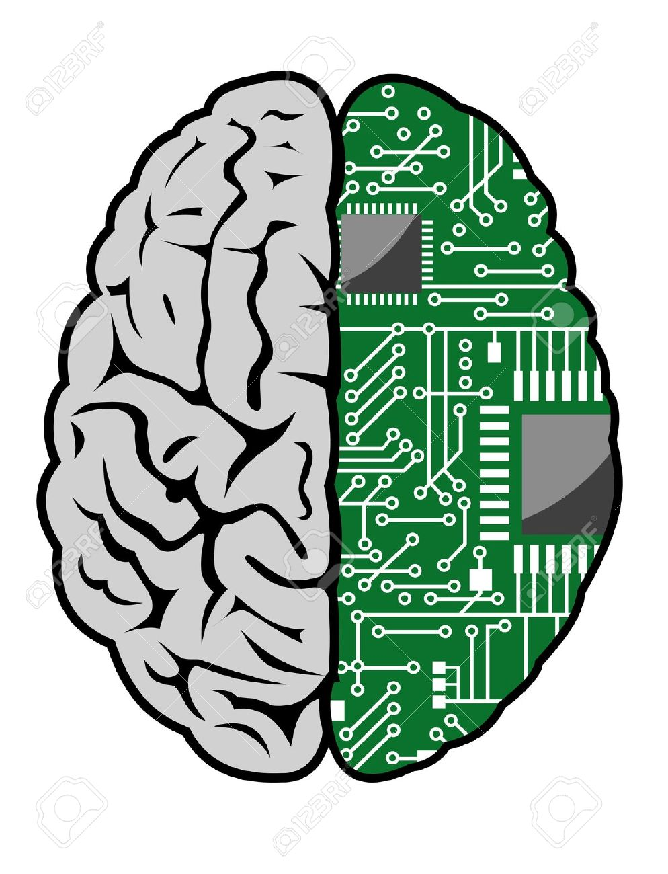

However, the development of AI has become a race between some of the greatest and powerful governments and companies in the world. People are not assessing the risks of this technology rather they are opting for the faster and more convenient option of developing AI. If we fail to foresee the risks of this development, we may indeed suffer the consequences.

If we want to continue improving our machines and devices the development and enhancement of their intelligence is inevitable. Suppose however that we develop a machine with superhuman intelligence. It will be impossible to have full control over that type of device. We may indeed be making a Faustian bargain by giving them the tools, to improve themselves far beyond human comprehension. AI is one of the only things that man has created that functions in a way we can't predict.



What we conclude with is both a viewpoint and a question. The theme of Joy’s article can be described as follows: Just because we can do something, should we do it? The reality is that these rapid technological advancements may instead be throwing fuel to a smoldering flame rather than simply leading us to a perfect utopia. The viewpoint we need to take away from this is that technology is a double-edged sword.



We should be cautious because we are developing technology that will have super human intelligence and capabilities. It would be foolishly to simply assume a techno-utopian view and hope things will work out fine. At the same time, we can’t just stop improving technology just because of the fear of the unknown. There’s also a strong deterministic argument to be made that technology will simply drive itself forwards regardless, due to market forces and innovation and that unlike what Moravec and likeminded people suggest it’s actually near impossible to control those.

For a final word we suggest you consider Murphy’s law-“Anything that can go wrong, will.” If you’re still not convinced consider the fact that this was actually Finagle’s law, which in itself shows that Finagle was right.(That’s Chernobyl btw)